Service version & os detection:
If we don’t given the domain or the ip to do the testing our network then we have to find our own ip and do the further steps:
Ip a
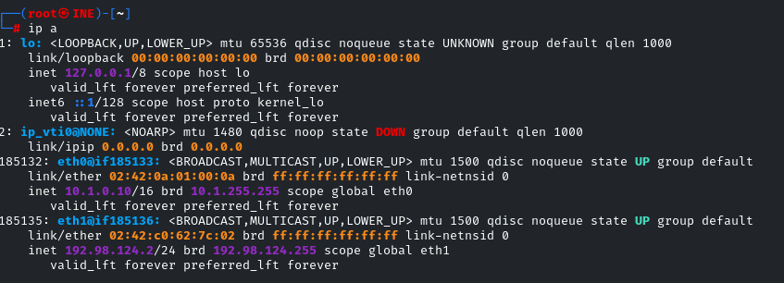
Host dioscovery:
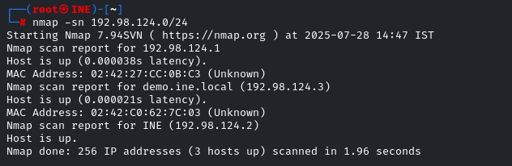
Nmap -Ss -p- -t4 IP-addess
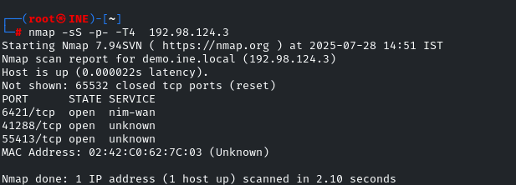
After that the step is to indentidfy which srvices are running on that port:
Nmap -sS -sV -p- -T4 ip address
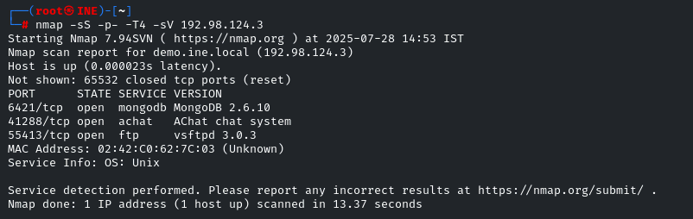

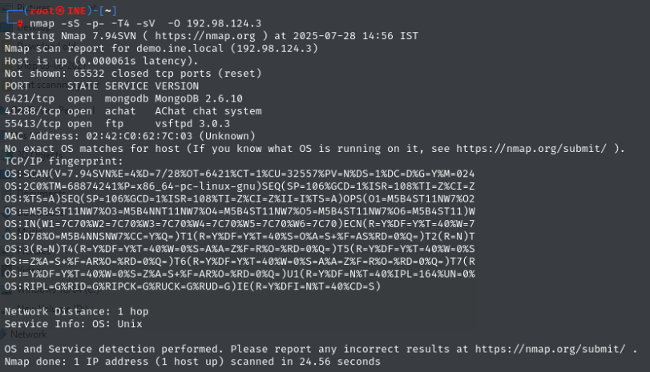
The nmap not able to guive exact operating system used but give use the overview of it. We use the NSE for that.

nmap -sS -p- -T4 -sV -O --osscan-guess 192.98.124.3
this will aggressively guess the operating system.
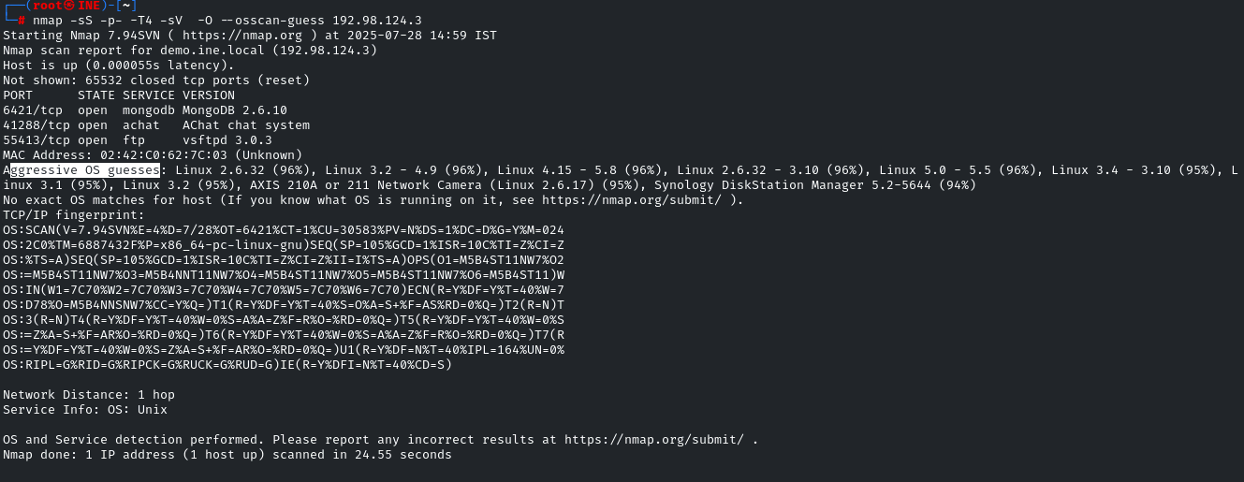

In the even where we cannot gane the accurate service version info/detection we use:

Then:
nmap -sS -p- -T4 -sV --version-intensity 8 -O --osscan-guess 192.98.124.3

version intensity range from the 0 to 8

